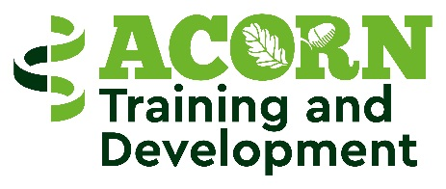

Client Agreement:

The Jersey Employment Trust (JET) is an independent charity that provides support & training and development towards employment to people with a disability or long term health condition. The training and development aspect of JET is based at ACORN and supports individuals to access a variety of volunteering/training projects, within the Acorn site and to access individualised voluntary placements within the local community.
This Agreement sets out the nature and quality of service that you can expect from JET

What you can expect from JET as a client. We will work in partnership to:

- Assist you with setting realistic and achievable vocational goals
- Hold regular reviews to monitor your progress and plan your next step.
- Link with other support services on your behalf where appropriate.
- Support you to be able to access relevant training opportunities
- Provide one to one support in voluntary placements where appropriate.
- Support you to improve your employability skills.
- Liaise with charities /non profit making businesses on your behalf to source suitable voluntary opportunities.
- Provide you with feedback to help you to make progress towards your vocational goals.

What JET expects from you as a client. We will expect you to:

- Attend all appointments and planned training / volunteering sessions.
- Notify us ASAP if you cannot attend an arranged appointment or are feeling unwell-
Please telephone: 01534 788963 or 788933
- Work in partnership with us to create realistic goals that support your vocational goals.
- Tell us if you no longer require our support.
- Tell us about any changes that may affect your engagement with our service or affect you achieving your vocational goals.
- Be honest with us and if something isn`t working well for you, please let us know so together we can look at alternative opportunities.

By signing below you are committing to the terms of this Client Agreement. JET is not a mandatory service but if you are in receipt of Income Support and Actively Seeking Work (ASW), we will be required to report to Social Security if you do not attend.

Client Signature:
Date:

JET Employee Signature: Date:

