Some people DO NOT have to wear a mask
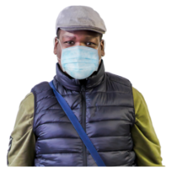  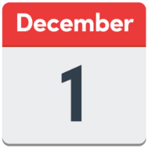 | From Tuesday December 1st  you have to wear a mask or a face shield in places that are inside
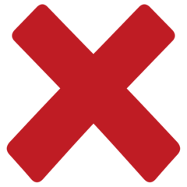 | Some people do not have to wear a mask if they have a special reason  This is called being exempt
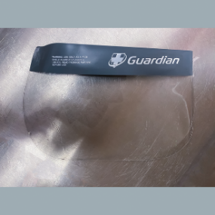 | If you are not able to wear a mask  you might be able to wear a clear face shield
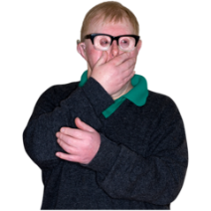  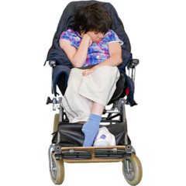 | You do not have to wear a mask if:  - You cannot put on, wear or take off a mask because of an illness, condition or disability  - Putting on, wearing or taking off your mask will make you very upset and anxious  - You need to speak to, or support someone who is lip reading and needs clear sound for communication
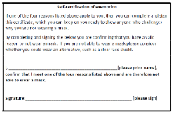 | If you cannot wear a mask because of these reasons, then you need to fill out an exemption certificate
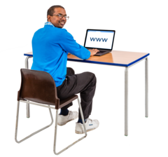 | You can get an exemption certificate form online  www.gov.je
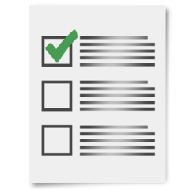 | You will need to tick a box to say why you cannot wear a mask  You do not need to give your name  You can download and print the certificate and card
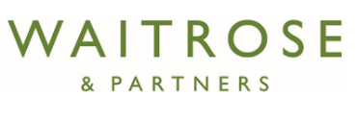  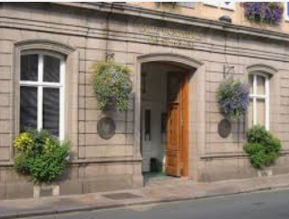  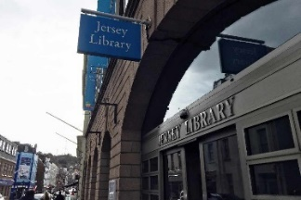 | You can also collect a certificate from:  - Your parish hall  - Libraries (town and Les Quennevais)  - Citizen’s Advice Jersey  - M&S, Waitrose and Co-op  - Beresford Street Kitchen  - Autism Jersey
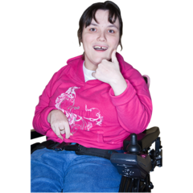 | You do not need to give any personal information when you collect the certificate or card
 | You can ask a family member or your carer to help you fill out the certificate
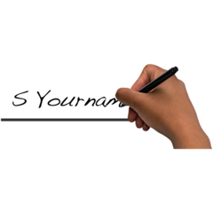 | You need to sign your certificate or a family member or carer can sign it for you
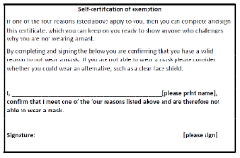  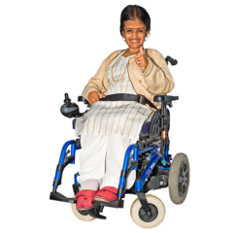 | You can keep this certificate on you ready to show anyone who might ask why you are not wearing a mask
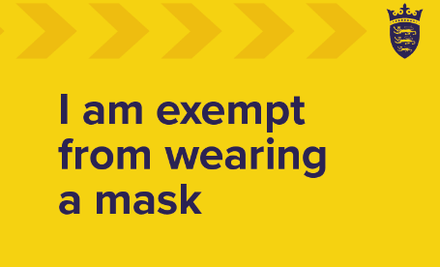 | You can have an exemption card to keep in your wallet or purse
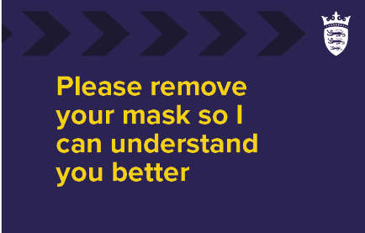 | It tells people you do not need to wear a mask  and if you need them to take their mask off to talk to you

https://www.gov.je/Health/Coronavirus/PublicHealthGuidance/Pages/WearingClothMasks.aspx.

