Activities that are high risk and activities that are lower risk
 | High risk activities
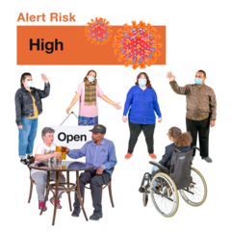 | This means that some activities give you a higher chance of getting coronavirus
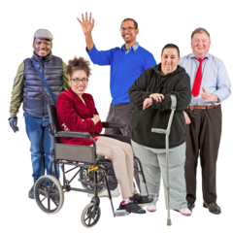 | These are activities with people you do not live with
 | These are activities where it is difficult to keep a 2 metre distance from other people and that are for longer than 15 minutes
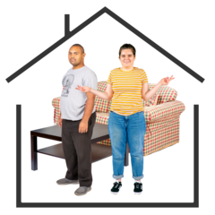 | These are activities that are indoors and not in your own home
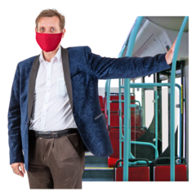 | These are activities where you will have to touch surfaces or items that other people you do not live with have touched
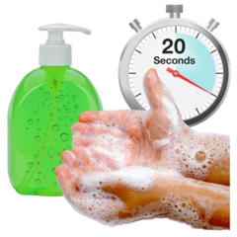 | This risk is less if you remember to wash your hands before and after activities for 20 seconds or use hand sanitiser
 | These are activities when you do not wear a face mask or face shield
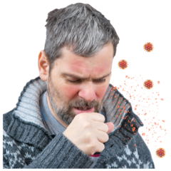 | These are activities that might include singing, shouting, coughing and breathing heavily with a group of people

 | Lower risk activities
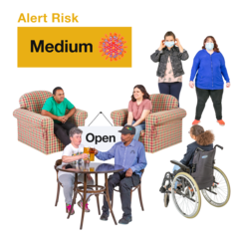 | This means that some activities give you a medium chance of getting coronavirus
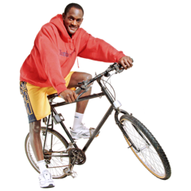  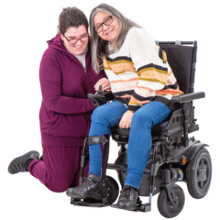 | These are activities done on your own or with people that you live with  If you spend time with people you do not live with, the less people the smaller the risk
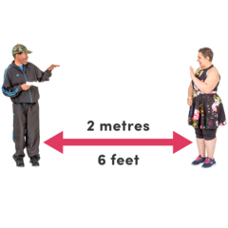 | These are activities where you can keep 2 metres distance from other people or is for less than 15 minutes
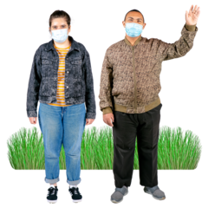 | These are activities that are outdoors
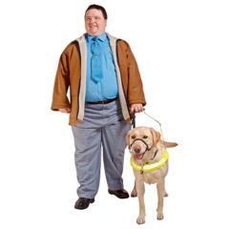 | These are activities where you will not have to touch surfaces or items that people you do not live with have touched
 | This risk is less if you remember to wash your hands before and after activities for 20 seconds or use hand sanitiser
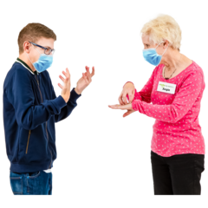 | These are activities where you can wear a face mask or face shield
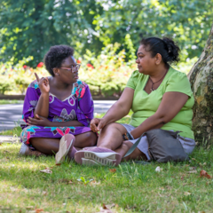 | These are activities with no need for shouting, breathing heavily and coughing

