Stay safe
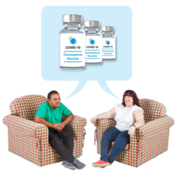 | Most people in Jersey have now had the corona virus vaccine.
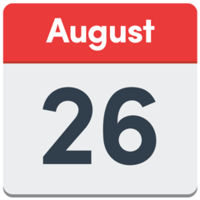 | So the government have made some more new changes.  The new changes are from Thursday 26th August 2021
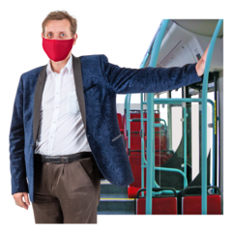 | You only have to wear masks or face shields in some places  - on the bus and at the bus station  - in a taxi  - at the harbour or airport  (please see exempt mask easy read)
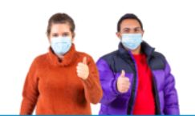 | It is still safer to wear your mask or face shield  - at the Hospital  - at the Doctors and Dentists  - at any health appointments  - when you are waiting in busy places
 | Places you can go
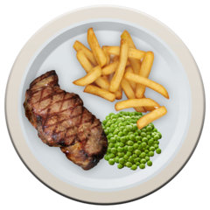  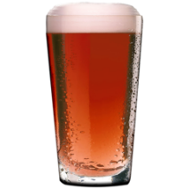  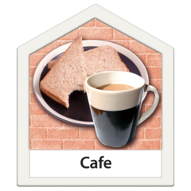  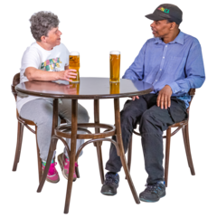 | You can go to all restaurants, cafes and pubs - even if they do not serve food.  You can be served and stand at the bar or at your table.  Any number of people can sit at a table and you can stay at your table for as long as you like.
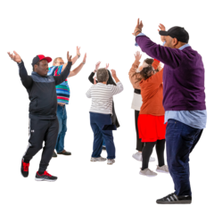 | You can go to nightclubs and you can sing and dance.  You can go to large events with lots of other people.
 | Seeing friends and family
 | You can have any number of people in your home and garden.
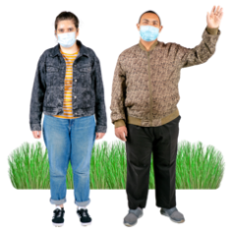 | You can meet any number of people outdoors.
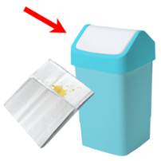  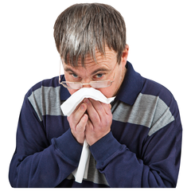 | Remember to keep others safe cough or sneeze into your elbow or a tissue.
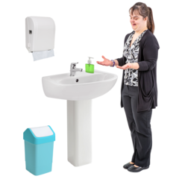 | Wash your hands  - when you get home  - before you eat  - before you touch your face
If you are worried or think you have any symptoms of Coronavirus.

You can call the Coronavirus helpline on:
Telephone: 01534 445566

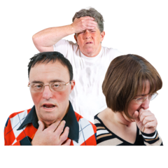  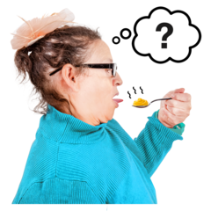 | The three main symptoms are:  - a new cough or one that does not go away  - a high temperature  - loss of smell or taste  Stay Safe

