Jersey Employment Trust Client Introduction Pack

Contents
- Mission Statement
- About Us
- JET Services
- Client Agreements
- Our Locations
- Service Charter
- Complaints & Appeals Procedure

Welcome to Jersey Employment Trust

MISSION STATEMENT
Our aim is to empower and facilitate people in Jersey with a disability and/or long-term health condition to maximise their potential to gain and maintain open employment through individual training and support.

ABOUT US
We are a supported employment service whose aim is to help people with a disability or long-term health condition to find and maintain open employment.
Jersey Employment Trust is made up of 3 different services, as the diagram shows:

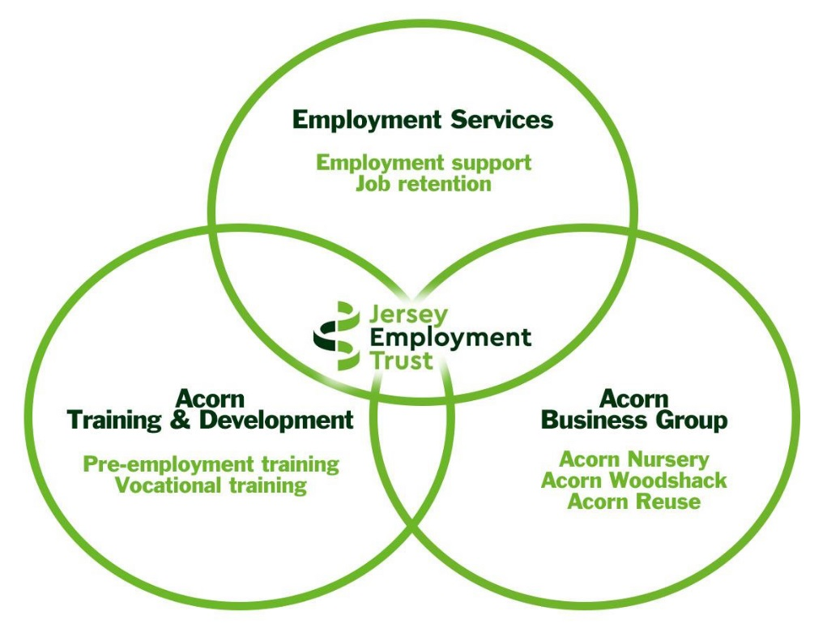

Our service is bespoke; we work with clients on a 1:1 basis to identify relevant training opportunities, access appropriate work experiences, placements & paid employment and to provide in-work support for as long as needed through your career.
We can provide you with a number of options to fit with your current status & employment goals.

JET Services

EMPLOYMENT SERVICES
Our Employment Service team is based at Oakfield and their role is to assist clients to find and secure employment opportunities. The types of support that can be provided includes:
- Assist with identifying & researching appropriate career paths
- Help prepare & update your CV’s
- Identify relevant training
- Source work experience and placement opportunities
- Assist with job searching & applications
- Provide interview preparation & practice
- In-work support & job retention
- Career development

Job Club
We run daily job clubs from our Kensington Chambers premises where clients can join an informal session with staff and receive assistance with job seeking, writing CVs and cover letter, completing application forms and sourcing training opportunities to enhance their skill set. We have accessible computers with assistive technology & our staff can provide you with the support that you require to use our IT facilities.
Employment Placement & Work Experience
JET offers an individualised canvassing service where we contact employers to help source an employment placement or work experience by promoting an individual’s skills and potential. We can advise an employer in relation to any reasonable adjustments to a role or work space, or identify any specialist equipment that required to enable a person to undertake a placement.

Interview Preparation & Practice
JET provides interview preparation and practice assistance to our clients. As well as helping you prepare for an upcoming interview, we can arrange a mock interview with a local employer who will provide feedback & offer tips and guidance on improving your interview technique. This type of feedback has proved invaluable to some people who have successfully secured employment.

In-work Support
JET provides our clients with the support required to help a person settle into work. JET continues to offer in-work support via regular communication with clients & employers for as long as needed. This can be done by regular visits to the workplace, lunch time catch ups or over the phone.
We understand that a change in someone's job role or a change of staff within a team could have an adverse effect on a person's health and sustainability in the workplace. JET is available to clients and employers to help provide any necessary support & guidance at such times.
We are also able to provide awareness training to employers & colleagues who work closely with a person with a specific condition, where appropriate, and can advise the employer on any minor adaptations to the premises or work routine, if necessary.

Job Retention
JET can provide support to any person who is finding it difficult to maintain tasks within their current job role due to a new medical condition or disability, changes or relapses in an existing condition, or a change in task or job role. We can provide advice, information, training in the workplace or assistance with aids and adaptations to help someone retain their employment.

Career development
JET can assist clients to develop a progression pathway to help them achieve their future career goals. We can support a client to prepare for upcoming workplace reviews or appraisals, or with looking for alternative work in a different company or sector.

14 – 21’s SERVICE
The 14 - 21 Service is the part of the Jersey Employment Trust that works specifically with younger clients. We work with clients aged 14+ with a disability or long-term health condition to help them plan a training or employment pathway and providing guidance and support towards achieving this.
JET offers a bespoke service to meet the requirements of each young person that we work with. We have a range of programmes and approaches depending on your age, experience and employment goals, as shown below:

World of Work
This programme is aimed at year 10 students (14/15 years old) and is designed to help build initial employment skills through focused activities and give an insight into different working environments. As part of this programme we visit employers across different employment sectors, such as Seymour Hotels, Cameron's Construction, Sandpiper & Bean Around the World. During these visits, participants undertake practical, work-based tasks to gain insight into the world of work.

Level Up
This is a 2 day programme during May half-term week, which is aimed at year 11 students (15/16 years old) and focuses on the practical aspects of getting a job. Participants will develop a CV, learn about where to look for jobs and practise their interview skills before having a mock-interview with a local employer.

1-to-1 Meetings
These are led by the student and can take place at JET, home or school. 1-to-1 meetings are an opportunity to build a relationship with the young person and provide appropriate support & guidance, both pastoral & employment-focused.

Careers Guidance & Employment support
We work with a client to complete a school transition plan or an employment vocational profile which identifies their work goals. After completing a person-centred action plan focused around employment goals, we work with clients to achieve these goals, which could include:
- Developing soft skills
- Identifying relevant training programmes such as Trackers or Prince's Trust
- CV preparation
- Interview skills
- Vocational work tasters
- Volunteering
- Work experience
- Internships
- Recruitment & job matching
- Initial on the job training
- Job retention & further skill development

Job Squad
Job Squad sessions help prepare young people to take ownership & responsibility for their employment search in a more structured manner, with a view them progressing to the employment team. The sessions are centred around consolidating previous job seeking experience, training clients how to prepare job applications and for interviews, exploring how to use these skills to increase their chances of successfully securing a placement or paid employment.

Driver Theory
This is an open access session for any client who is considering obtaining their driver's licence. These sessions are led by our Employment Coordinators and participants will have access to computer-based mock tests with answers. These supporting learning sessions focus on study skills & give guidance on passing the Jersey Driver Theory test successfully.

ACORN TRAINING & DEVELOPMENT SERVICE
Based at our Acorn site in Trinity, the Training & Development team work with clients to develop employment skills & build self-confidence. They support clients to identify realistic & relevant vocational goals and work with them to identify appropriate training / volunteering opportunities to progress towards these goals. Coordinators hold regular reviews with clients in order to evaluate progress and plan the next steps on their vocational journey.
Some of the opportunities on offer through our Training & Development Service are our Acorn Group Training Projects, which include:
Allotment - Sowing, growing & harvesting a variety of seasonal fruit & vegetables
Furniture Up-cycling - Transforming donated furniture into bespoke, one-off pieces
Re-purposing - Transforming broken or damaged items from Reuse into new products
Wooden Gifts - Creating unique gifts from donated timber
Textiles - Using donated fabrics to create quality, textile products
Tool course - Training in the safe use of hand tools and power tools, to make bespoke garden products

VOLUNTEERING SCHEME
Volunteering plays a very important role in the community and charities often rely on the assistance that volunteers can provide. We offer a bespoke 1:1 supported volunteering service to give clients an opportunity to try new experiences, increasing their confidence and identifying their skill sets, whilst also helping the community. Volunteering can be used as a stepping stone onto employment or can be a valued long term vocational activity. Some of the opportunities include:
- Assisting with retail tasks within charity shops (customer facing or helping behind the scenes)
- Undertaking admin tasks for charitable organisations
- Supporting organisations that work with elderly
- Helping with tasks for charities that support animals/local wildlife
- Assisting organisations that support children/families
- Helping in Charity cafes
- Supporting charities with maintenance/gardening tasks

ACORN PLACEMENTS
As part of our workplace training programme, clients have the opportunity to undertake a 4-6 week work experience placement in a realistic employment environment within one of the business areas at Acorn; either in our Woodshack, Nursery or Reuse Shop or our Acorn Reuse Centre at La Collette.
As part of this work experience they learn about the specific area of the business in which they are working, as well as develop skills such as team work, time management and customer service skills. Some of the opportunities available include:
Woodshack - Sorting, de-nailing & preparing donated timber ready to be re-sold or made into bespoke furniture or kindling
Kindling - helping produce kindling from recycled wood
Greenhouse - Assisting with planting, growing & caring for bedding plants
Reuse Shop - Helping to sort, quality-check, clean & safety-test donated items at our Reuse shop
Acorn Reuse Centre – assist with receiving donations for our Reuse Shop from members of the public.

Employment Services Client Agreement
The Jersey Employment Trust (JET) is an independent charity that provides support & training and development to people with a disability or long-term health condition to enable them to access and retain open employment. This agreement sets out the nature and quality of service that you can expect from us at JET.

What you can expect from JET as a client. We will:
- Assist you with putting together an action plan that supports your job goals.
- Support you to find employment opportunities.
- Link with other support services on your behalf, where appropriate.
- Provide facilities for job searching and provide support at Job Clubs.
- Support you to be able to access relevant training.
- Provide one to one support in the workplace, where appropriate.
- Support you to improve and update your skills in the workplace.
- Liaise with employers on your behalf to source suitable vacancies and work experience opportunities.
- Provide you with feedback to help you to make progress towards your job goals.
- Act in accordance with our Service Charter.

What JET expects from you as a client. We will expect you to:
- Attend all appointments and job clubs sessions arranged for you.
- Notify us if you cannot attend an arranged appointment or are unwell.
- Work in partnership with us to create an action plan that supports your job goals.
- Take responsibility to complete actions agreed in meetings.
- Take ownership for your job search with our support.
- Tell us if you find work and no longer require our support.
- Tell us about any changes that may affect your job goals and action plan.
- Be honest with us and provide feedback.
- To act in accordance with JET’s ‘Acceptable Client and Customer Behaviour Policy & Procedures.’

By signing below you are committing to the terms of this Client Agreement. JET is not a mandatory service but if you are in receipt of Income Support and Actively Seeking Work (ASW) we will be required to report to Social Security if you do not attend.
Client Signature: Date:

Jet Employee Signature: Date:
Acorn Client Agreement
The Jersey Employment Trust (JET) is an independent charity that provides support & training and development towards employment to people with a disability or long term health condition. The training and development aspect of JET is based at ACORN and supports individuals to access a variety of volunteering/training projects, within the Acorn site and to access individualised voluntary placements within the local community.
This Agreement sets out the nature and quality of service that you can expect from JET

What you can expect from JET as a client. We will work in partnership to:
- Assist you with setting realistic and achievable vocational goals
- Hold regular reviews to monitor your progress and plan your next step.
- Link with other support services on your behalf where appropriate.
- Support you to be able to access relevant training opportunities
- Provide one to one support in voluntary placements where appropriate.
- Support you to improve your employability skills.
- Liaise with charities /non-profit making businesses on your behalf to source suitable voluntary opportunities.
- Provide you with feedback to help you to make progress towards your vocational goals.

What JET expects from you as a client. We will expect you to:
- Attend all appointments and planned training / volunteering sessions.
- Notify us ASAP if you cannot attend an arranged appointment or are feeling unwell-
Please telephone: 01534 788963 or 788933
- Work in partnership with us to create realistic goals that support your vocational goals.
- Tell us if you no longer require our support.
- Tell us about any changes that may affect your engagement with our service or affect you achieving your vocational goals.
- Be honest with us and if something isn`t working well for you, please let us know so together we can look at alternative opportunities.

By signing below you are committing to the terms of this Client Agreement. JET is not a mandatory service but if you are in receipt of Income Support and Actively Seeking Work (ASW), we will be required to report to Social Security if you do not attend.
Client Signature: Date:

JET Employee Signature: Date:

Our Locations
OAKFIELD BUILDING
The head office is where the employment teams, admin team and some of the management team is based. The offices are used to have one to one meetings with clients, deliver training and we also run some small training sessions.
Oakfield Building, T: 01534 788900
Highlands Campus, E: admin@jet.co.je
La Rue du Froid Vent,
St Saviour
JE2 7LJ

Directions
We are located at the Oakfield Building, which is in the grounds of Highlands College. Coming from St Helier, go up to the very top of Wellington Hill until you reach the yellow line, turn left down Bon Air Lane (La Rue du Froid Vent) for 250 metres, then turn left into the Highlands College entrance. Oakfield is the large blue building on the right directly after Hautlieu School.

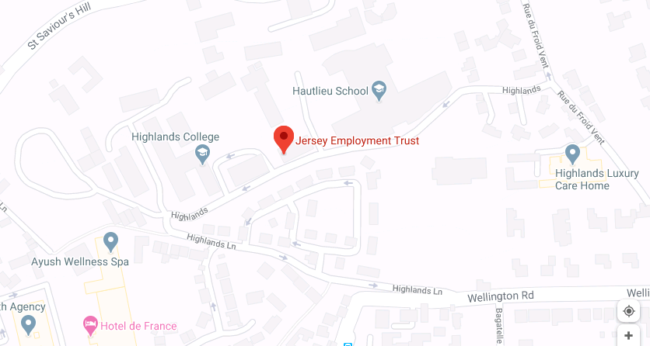

Travelling by bus
You can catch the number 3 bus and get off at the Bon Air Lane bus stop.
You can also take the number 13 or 23 bus and get off at St Saviour’s Church and walk along Bon Air Lane & then down past Hautlieu School.

For more information on bus times please go to - http://libertybus.je/

KENSINGTON CHAMBERS JOB CLUB
Our premises in Kensington Place has been specifically designed to accommodate job clubs, training courses & one-to-one meetings with clients. Job club sessions run every day at this venue with staff available to assist with you as required. The facilities include computers, free WiFi & internet access, use of the telephones to contact employers, information on courses & services and refreshments.
Kensington Job Club T: 01534 788940
46-50 Kensington Chambers
Kensington Place
St Helier
JE4 0ZE

Directions

From Liberation Station bus terminal - walk along the Esplanade & cross over Gloucester Street at the traffic lights. Continue past Royal Bank of Canada (Gaspe House) and turn right onto Kensington Place.

From The Parade - walk past Jersey General Hospital towards Cheapside, then turn left onto Kensington Place. Kensington Chambers is on the left opposite Café Spice.

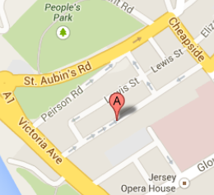

ACORN
Acorn is made up of three parts; the horticultural nursery, Re-use, and the Woodshack. All three are based at our Acorn premises in Trinity and form the trading and skills development area of JET.
Our Acorn Group Projects and Volunteering Scheme all operate from our Acorn Training & Development Service.
Acorn Training & Development T: 01534 788930
La Rue Asplet E: acorn@jet.co.je
Trinity
JE3 5JF

Directions
We are located 300 metres from Trinity Church. If you are coming from town, go up Trinity Hill, all the way to the yellow line just past the Howard Davis Farm. (Trinity Church and the Trinity Arms are on your right) Turn left down La Rue Asplet, then right onto La Rue au Sellier. The entrance to Acorn is 100 metres along the road, on the left.

Travelling by bus
You can catch the number 4 bus and get off at Trinity Church.
From the Church, walk towards La Rue d’Asplet, about 200m down on the right hand side is the pedestrian entrance to Acorn.

For more information on bus times please go to - http://libertybus.je/

ACORN REUSE – LA COLLETTE
Our Acorn Reuse Centre, based at the Household Reuse & Recycling Centre at La Collette, is open most days of the week for members of the public to drop off donations for our Acorn Reuse shop. Our staff will receive and sort donated these items ready for them to be repaired, recycled, upcycled or sold in our Reuse Shop at Trinity.

Acorn Reuse Centre T: 01534 483251
Household Reuse & Recycling Centre E: donate@acorn.co.je
Recycling Park
La Collette
St Helier
JE2 3NX

Directions
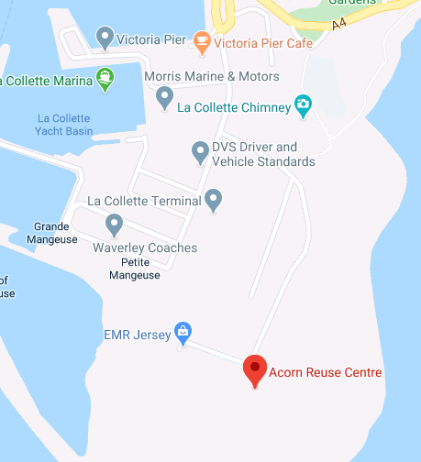
From Liberation Station, walk towards Commercial Buildings (the big yellow Norman’s Building on the harbour), follow the road around the harbour towards La Collette. Continue past the turning for Mount Bingham and take the next left turn towards the Energy for Waste plant. Follow the road for approximately 500m until you reach the gates for the Household Recycling & Reuse Centre. Acorn Reuse Centre is through the gates on the left hand side.
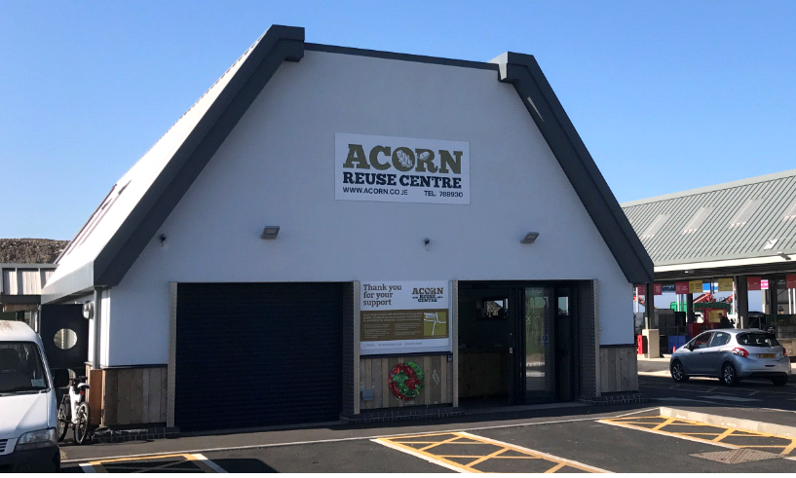

Service Charter
Jersey Employment Trust's Service Charter sets out the nature and quality of service that you can expect from us at JET whether you are a service user, a supportive employer or partnership agency. Below you will find the Charter, which includes our various policies & outlines, what you can expect from JET as a service and what we expect from you, the client.

Equality and Diversity
The Trust seeks to promote equality of opportunity and treatment for all persons in relation to all of its activities, such as employment training and employment support for service users, employment of JET staff, and liaison with employers and other agencies. We will accommodate diversity, ensuring our workforce and user groups represent and reflect the community in Jersey.
As Jersey is following a phased approach in implementing protected characteristics of the Discrimination (Jersey) Law 2013 over a number of years, the Trust has taken the decision to adhere to the spirit of UK legislation and guidance on best practice; this is reflected in JET’s own Equality and Diversity Policy.

Measuring Performance
It is important for us to continually measure and evaluate our performance to ensure we meet the best possible service standards.

We will measure our performance through:
- Evaluating and monitoring our services in relation to the rights set out in the Service Charter
- Working with user groups to ensure we monitor our performance

This charter has been developed in partnership with service users, staff and partner agencies. JET uses active risk management throughout the company & operations. The charter will be reviewed every 2 years. Other JET policies to refer to include (all available on request & in accessible and alternative formats):
Data Protection Policies Equality and Diversity
Whistle Blowing Policy Safeguarding Policy
Client Agreement ICT Client Policy
Health and Safety Smoking Policy
JET Quality Assurance Standards Complaints and appeals
Client Agreement
In order to provide clients with the best possible service, we have a set of mutual expectations, which can be found below:

What we expect from you:
- Respect for other service users, staff, resources and facilities
- Adherence to safe and healthy work practices and policies
- Sign up to the Client Agreement
- Participate in reviews and overall service evaluation
- Provide up to date and accurate information about yourself
- Provide feedback to allow us to sort problems out informally in the first place and as soon as possible

What you, the client, can expect from JET:
- Dignity, confidentiality and respect
- Access to appropriate training and employment opportunities
- Accurate information in order to make informed choices
- Safe and healthy working practices and policies
- Long term employment and training support appropriate to your needs
- Opportunity to communicate, express opinions, be consulted and listened to
- Links with other relevant services
- Timely response to feedback to enable us to sort out possible problems as soon as possible
- Active and ongoing risk management

Feedback
JET wants to know your views of our service and welcomes all feedback in any of the following ways:
Tel: 01534 788900
Email: admin@jet.co.je

We also have suggestions boxes at our Oakfield and Acorn premises where you can leave feedback.

Complaints & Appeals Procedure
The Jersey Employment Trust (JET) is committed to providing good quality services. We recognise however, that we sometimes get things wrong or make mistakes. To deal with this we have a complaints procedure.
We do not look on complaints as unwanted. In fact, they often help us to see where our services or procedures might be improved. So, do let us know where you feel we have made a mistake or done something which you found unsatisfactory or unacceptable. Even if you do not think your particular concern amounts to a 'complaint' we would still like to know about it. You may help us to deal with something we would otherwise overlook.

Complaints and Appeals Procedures
We will:
- Welcome all feedback, including complaints, and deal with them positively
- Help you to write down your complaint, take details over the telephone, or your chosen method of contact
- We will record data on complaints, comments and compliments and this will be used to help to improve our service in accordance with JET’s Data Protection Policy

The JET Complaints and Appeals Procedure can be found on our website, www.jet.co.je
If you are not satisfied with any outcome or decision the Complaints and Appeals Procedure can be implemented.

How to Make a Complaint

Step 1: Contacting us
The first step is to talk to a member of JET staff. This can be done quite informally, either directly or by telephone.
Usually, the best staff member to talk to will be the person who dealt with the matter you are concerned about, as they will be in the best position to help you quickly and to put things right. If they are not available, or you would prefer to approach someone else, then ask for their relevant line manager.
Some key contact details are provided below, you can email or telephone the relevant person directly to discuss your complaint:

Name | Job Title | Telephone | Email
Amanda Berry | Acorn HR Manager | 01534 788939 | a.berry@jet.co.je
David Rose | Risk & Strategy Manager | 01534 788995 | david.rose@jet.co.je
David Rudman | Reuse & Retail Manager | 01534 788930 | david.rudman@jet.co.je
Emma Powell | Employment Services Manager | 01534 788912 | emma.powell@jet.co.je
Fiona Scott | Acorn T&D Client Services Manager | 01534 788933 | fiona.scott@jet.co.je
Sarah Boydens | Operations & Quality Assurance Manager | 01534 788974 | sarah.boydens@jet.co.je
Steve Pearce | General Manager | 01534 788991 | steve.pearce@jet.co.je

We will try to resolve the problem on the spot if we can. If we can't do this, for example, because information we need is not to hand, then we will take a record of your concern and arrange the best way and time for getting back to you. This will normally be within five working days or we will make some other arrangement acceptable to you.

Step 2: Taking your complaint further
We hope you will only feel the need to make a formal complaint as a last resort and that you will complain to the person dealing with the matter first to give them a chance to put things right. However, if you are still unhappy, the next step is to put your complaint in writing to Jocelyn Butterworth the Executive Officer of JET, setting out the details, explaining what you think went wrong and what you feel would put things right. If you are not happy about writing a letter, you can always ask a member of staff to take notes of your complaint. You should make sure you agree with what they have recorded and that they provide you with your own copy for reference. This record will be passed promptly to the Executive Officer to deal with.
Once the Executive Officer receives a written complaint, she will arrange for it to be fully investigated. Your complaint will be acknowledged in writing within five working days of receiving it and the letter will say when you can expect a full response. This should normally be within three weeks unless the matter is very complicated, such as where other organisations need to be contacted. Where this is the case, we will still let you know what action is being taken and tell you when we expect to provide you with a full response.
You can contact Jocelyn by writing to her at our Oakfield Building address, or via email at ceo@jet.co.je

Step 3: The next stage
If you are not satisfied with the Executive Officer's investigation you can take your complaint to the JET Board. JET is a registered charity and as such is managed by a Board of Trustees. All materials relating to your complaint and to the Executive Officer's investigation will be sent to the Chair of the Board (contact details will be provided for you). He/she will appoint a member of the board and let you know within seven working days that they have received your complaint and who will be dealing with it; he will also inform you when to expect a full response from them.

Appeals Procedure
If you are not satisfied with the outcome from all of the above 3, you can appeal to the Chair of the Board of Trustees who will review the evidence and make a casting decision.
In exceptional circumstances following the appeal; if you are still not satisfied you can request an independent review. An independent body would be appointed to carry out an investigation.

