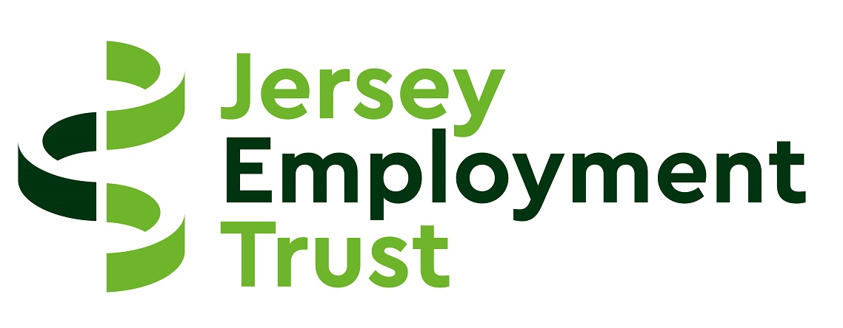

JERSEY EMPLOYMENT TRUST

Acceptable Client and Customer Behaviour
Policy and Procedures

Introduction
The policy is designed to reduce the level of risk which staff working at the Jersey Employment Trust (JET) might face when dealing with clients or customers whose behaviour is unacceptable. JET has made it clear that unacceptable behaviour towards staff, clients, volunteers or customers will not be tolerated. In this regard, JET has a zero tolerance policy to unacceptable and anti social behaviour.

In accordance with Health and Safety Legislation it is the responsibility of every Manager and employee to ensure that arrangements are introduced to minimise any identified risks (physical or emotional).

All staff operating at JET premises also have a part to play particularly in relation to the reporting of incidents. It is the responsibility of all staff to co-operate with their line Manager/Team Leader in any activity designed to reduce the risk of incidents occurring. Staff should be aware that their behaviour can influence the behaviour of others.

Definition of unacceptable behaviour

Unacceptable client or customer behaviour is:

- Any act of written or verbal abuse, including those of a discriminatory nature;
- Threatening behaviour;
- Intimidation;
- Harassment (including sexual harassment);
- A threat, attempted or actual physical assault;
- Or any other act;

that causes staff, clients, volunteers or customers to feel anxious, threatened, frightened or physically at risk and is directed at them because of their work at or engagement with JET. This also applies to incidents that take place outside the workplace, including in non-working hours that is a result of working at or engaging with JET.

The role of the Managers, Team Leaders and supervisors

Health and Safety Legislation requires that all the work processes that take place both within and outside the workplace are risk assessed and that control measures are put in place to minimise any identified risks. It is the responsibility of the Managers, Team Leaders and supervisors to ensure that this is carried out. This includes giving due consideration to verbally abusive risks.

The role of staff

Under Health and Safety Legislation, all staff are responsible for their own safety and that of others and for complying with any procedures that are put in place for their health, safety and wellbeing.

Staff should recognise that some of the common reasons why incidents occur could be, but are not limited to:

- Application of business rules
- The customer was not happy with the way they were treated/spoken to;
- Customer felt they were being passed from pillar to post;
- Outside influences, domestic difficulties, employment problems which may be placing the customer under severe pressure;
- Application of sanctions by other agencies;
- Alcohol or drug abuse;
- Mental health problems;
- Attitude of staff;

Serious incidents

Definitions of serious incidents are:

- An actual, attempted or threat of assault
- Damage to property
- Harassment and stalking (including sexually motivated behaviour)
- Any other incident which may cause serious harm or distress

In the event of a serious incident staff must report the matter to their line manager without delay, or in the event of an assault actually occurring dial 999 for Police assistance. Staff are empowered to call 999 as they see fit using their professional judgement as the situation demands.

Threats and verbal abuse directed face to face at staff

If a client or customer becomes abusive or threatening toward staff in the Reuse Shop or any other public area operated by JET the following action should be taken:

• The member of staff member should clearly advise the customer that unless they are able to continue the discussion in a civilised manner they will be asked to leave the premises;
• If, despite the warning, the behaviour does not improve the staff member should advise the customer they will no longer engage with them and call a Manager or Team Leader and advise the customer of this. The member of staff should keep a safe distance from the customer;
• The Team Leader or Manager should try to defuse the situation, perhaps instructing the customer to leave the shop.
If the customer continues to act inappropriately, refuses to leave the shop/business premises and the situation is escalating the Team Leader or Manager should advise them that they will call the Police and proceed to do so if required.

Threats and verbal abuse directed at staff over the telephone

If a client or customer becomes abusive or threatening on the telephone the following action should be taken:

- The member of staff taking the call should clearly advise the customer that unless they are able to continue the discussion in a civilised manner the call will be terminated;
- If, despite the warning, the behaviour does not improve the call should be politely terminated and the matter recorded.
- A member of the senior management team and their line manager should be advised by email of the incident.

Staff actions following an incident

All incidents must be reported to the senior management team and a person’s line manager as soon as possible (preferably by email). The information included in the email should include the follow:

- The time, date and location of the incident
- The name of the person who has allegedly breached this policy;
- Other members of staff who witnessed the incident;
- Any other person who witnessed the incident
- A description of the incident
- The harm, damage or distress caused

It should be noted that in cases where abusive language is used (i.e. swearing) the actual words said should be recorded and not generic terms (e.g. “Mr X was swearing at me”).

Managers and Supervisors - actions following an incident

Managers and Supervisors will:

- Give staff the opportunity to leave the environment in which the incident took place immediately following an incident.
- Sufficient time to report the incident.
- Give empathy to those most affected by the incident.
- Recognise the feelings of staff.

On receipt of an incident report, the Executive Officer (or in her absence another member of the senior management team) shall nominate a sub group of the senior management team to consider the incident and an appropriate response. A meeting of group shall meet as soon as practicable. The group may co-opt any other member of staff onto the group as they see fit to assist with determining an appropriate course of action.

This group shall also liaise with the HR manager to ensure appropriate support is available to staff members who may have been detrimentally affected by the incident. Furthermore, the group shall raise and make recommendations to the Strategy and Risk Manager if they identify improvements in risk management can be improved upon.

There are various actions/control measures that can be taken when an incident takes place, depending on the nature and severity of it. These actions include, but are not limited to:

- Issue an oral warning – this should always be done by at least 2 members of staff
- Issue a warning letter – informing the alleged perpetrator that their behaviour has been unacceptable and that a repeat of such an incident may result in the withdrawal of services
- Interview the perpetrator - to gain a fuller understanding of the possible reason for their actions
- Engage with other agencies – make contact with external agencies e.g. police, probation office, mental health services
- Withdrawal of services – write to the perpetrator informing them that their behaviour has been unacceptable and that they are no longer permitted to access JET services.
- Restrict Access to Acorn Site – advise the customer they are no longer to access the Acorn Reuse shop

Review

This policy and procedure shall be reviewed by the Strategy and Risk Manager every 2 years or sooner if the situation demands.

