Self-isolating
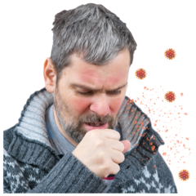 | Coronavirus can make people very ill
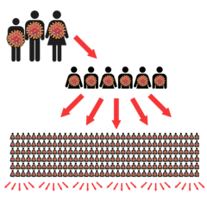 | The government want to slow  down the spread of Coronavirus
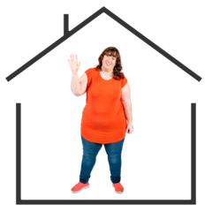 | Self-isolation is one way that we can do this
 | Self-isolation means staying at home and not leaving it
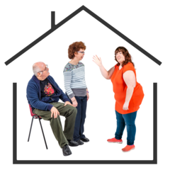 | This means you cannot meet other people and you are less likely to get ill
 | When you need to self-isolate
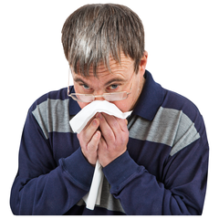 | You will need to self-isolate if you have any symptoms of coronavirus
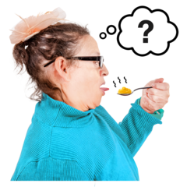 | The three main symptoms are:  - a new cough or one that does not go away  - a high temperature  - loss of smell or taste
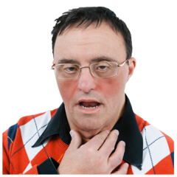  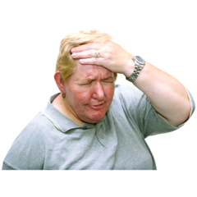 | Other symptoms are:  - headaches  - tiredness  - muscle ache  - sore throat  - vomiting and diarrhoea
If you are worried about any of the symptoms you can call the

COVID helpline

Telephone: 01534 445566

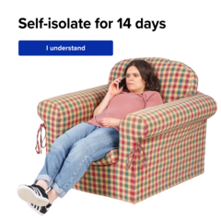 | They will tell you what to do next
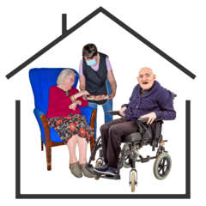 | You might be asked to self-isolate if you are at high risk of getting  very ill if you get coronavirus
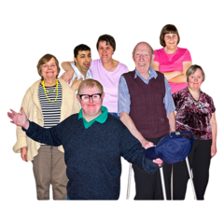 | You are at higher risk if:  - you are over 70 years old  - you have Downs Syndrome  - you have other health  conditions  - you take medicines that make it harder for your body to fight infections
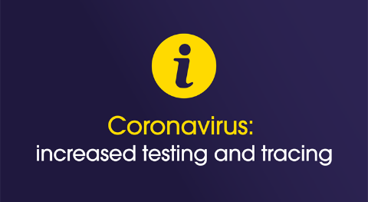 | You might be asked to self-isolate if you have been contacted by the track and trace team
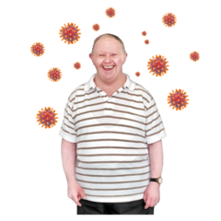 | This means that you might have been near to someone who has tested positive for Coronavirus
 | What self-isolation will mean for you
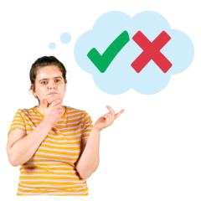 | If you are asked to self-isolate there are some things you can do and some things you will have to stop doing
 | Things you can do:
 | You can stay in your own home
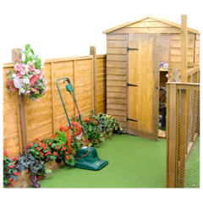 | You can go in your garden if you have one
 | Open your windows to let fresh air in if it is warm enough
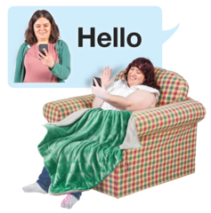 | Talk to friends and family on the phone
 | Things you cannot do:
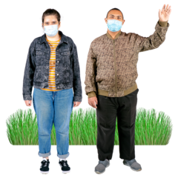 | Leave your house or go for a walk  If you have a dog, you will need to get someone to walk it for you
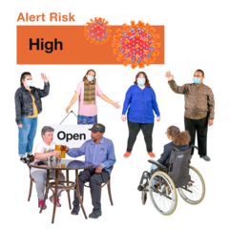 | Go out to places where there are lots of people
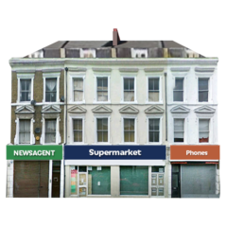 | Go out to the shops
 | Go to activities like the pub, gym or swimming pool
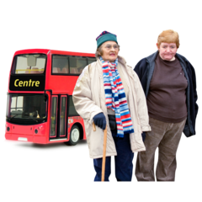  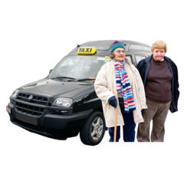 | Use public transport like the bus or a taxi
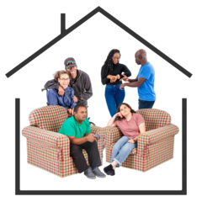 | Have friends or family to your house
 | Getting the things you need if you are self-isolating
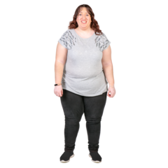  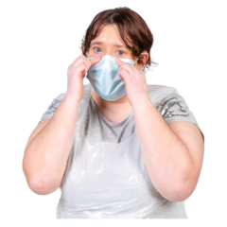 | If you are supported by staff you will still get your support
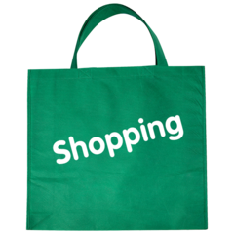  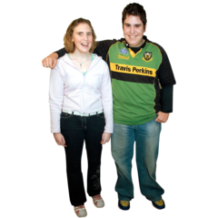 | Your friends, family and support will help you get your food shopping, medicines and anything else you need
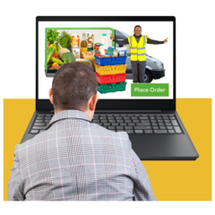 | You can order things online like a take away or shopping
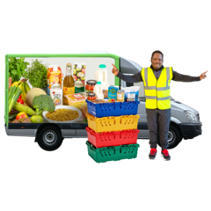  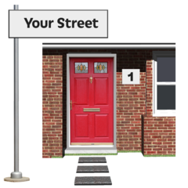 | The delivery driver or postman will not be able to bring anything into your house they will have to leave it at the door
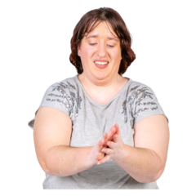 | Your support staff will take extra care to keep you and themselves safe
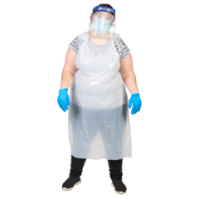 | This means they will be wearing protective clothing such as a mask, gloves and an apron
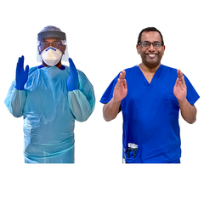 | If you have tested positive for Coronavirus then your support staff will be wearing protective clothing
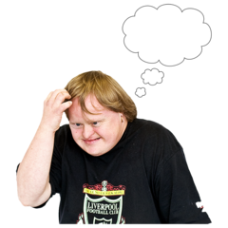 | You might feel worried and scared, this is okay
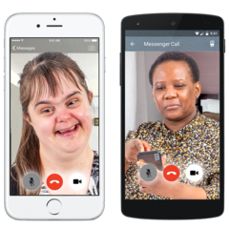 | Remember you can talk to your support staff, your Doctor, Social Worker, friends and family  This will help you feel better

