Seeing your friends and family over Christmas and New Year

to | From 23rd December 2020 to January 5th 2021  There are new rules about seeing your friends and family over Christmas and New Year
10 | You can see up to 10 people inside a house or garden  You can only do this on Christmas Day and Boxing Day  You must only do this once in a day
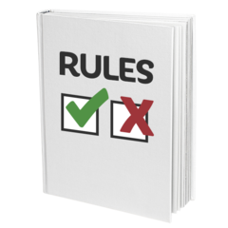 | It is now the law that you cannot meet more than 10 people in your home or garden  This means if you break the law you can be arrested by the Police  COVID-19 (Gathering Control) (Jersey) Order 2020
Try to meet with the same group of people

This means you are less likely to get coronavirus

10 | 10 people can meet outdoors in public places  You can meet at the beach, in a park or in a lane  You must stay 2 metres away from other people
It is the law that you cannot go to a meeting of more than 10 people outside

This means if you break the law you can be arrested by the Police

COVID-19 (Gathering Control) (Jersey) Order 2020

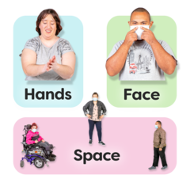  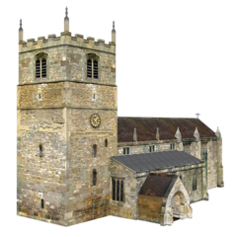 | People who do not have to follow these rules are:  - children under 3  - people who are going to a church. You must wear a mask and stay 2 metres apart
 | These new rules are to keep you safe and to stop the spread of coronavirus
 | Stay safe and have a merry Christmas and a happy New Year
 | For more information go to www.gov.je/coronavirus

