Stay safe
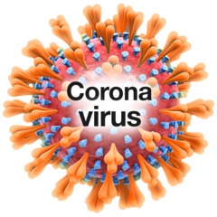 | Some people in Jersey have coronavirus
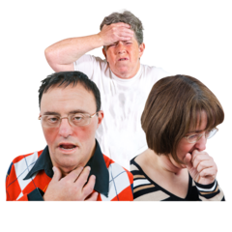 | Coronavirus can make you very ill
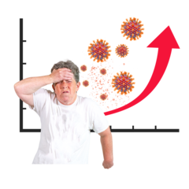 | The government has made some new changes to stop coronavirus spreading
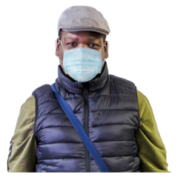 | From December 1st you have to wear masks or face shields in places that are inside  (please see ‘mask exemptions’)
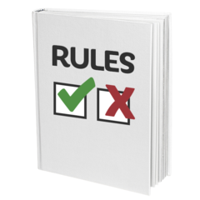 | This is a rule  It is to keep you and other people safe
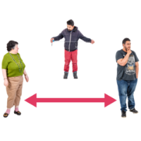  2 metres | You need to stay 2 metres away from other people
 | Some places are now closed to stop the spread of coronavirus
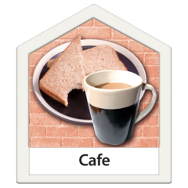 | All cafes, restaurants, pubs and hotels are closed
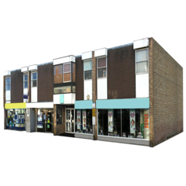 | Shops that sell clothes, jewellery, books and furniture are closed
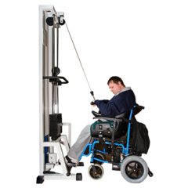 | Swimming pools, gyms and exercise classes are closed
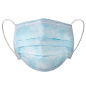  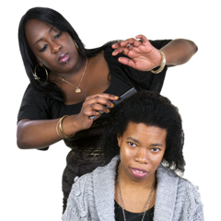 | Hairdressers and beauty salons  are closed
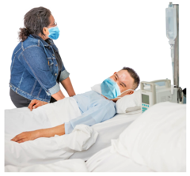 | You cannot visit friends and family in hospital
 | Places you can still go
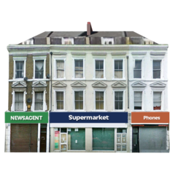 | You can go to the supermarket, pet shop, chemist and petrol station  Stay 2 metres away from other people
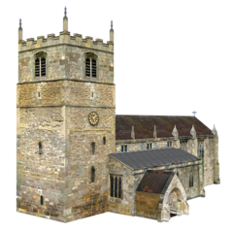 | You can go to church if you book a place  Stay 2 metres away from other people
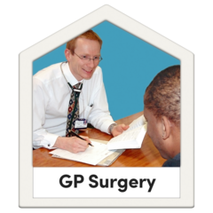  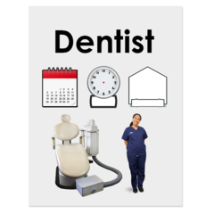 | You can go to the doctor, dentist and any health appointments  You must go on your own unless you need a carer to come with you  Follow instructions from staff
You can exercise outdoors

Stay 2 metres away from other people

 | You can order a takeaway
From 23rd December 2020 to January 5th 2021

There are new rules about seeing your friends and family over Christmas and New Year

(Read ‘Seeing your friends and family over Christmas and New Year’)

10 | You can see up to 10 people inside a house or garden only on Christmas Day and Boxing Day  You must only do this once in a day
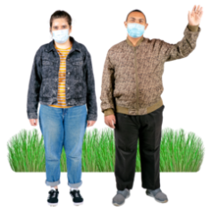  10 | 10 people can meet outdoors in public places  You can meet at the beach, in a park or in a lane  You must keep 2 metres away from other people
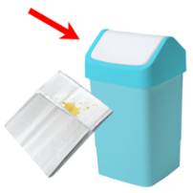  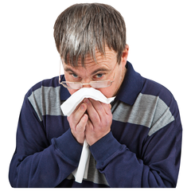 | Remember to keep others safe; cough or sneeze into your elbow or a tissue,  put the tissue in the bin and wash your hands
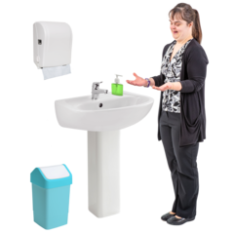 | Remember to stay safe you must wash your hands
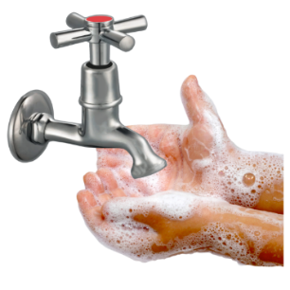 | Wash your hands  when you get home,  before you eat and  before you touch your face
If you think have any symptoms of Coronavirus
you can call the Coronavirus helpline on:

Telephone: 01534 445566

The three main symptoms are:

- a new cough or one that does not go away
- a high temperature
- loss of smell or taste

There are lots of things we can do to stay safe

If you are worried talk to your friends, family or support worker
 | Stay safe

