Stay safe
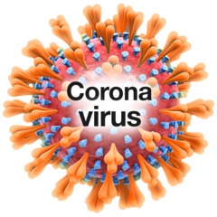 | Not many people in Jersey have coronavirus now
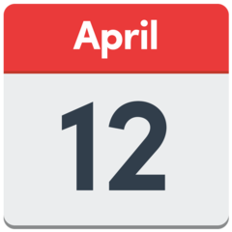 | So the government have made some more new changes  The new changes are from Monday 12th April 2021
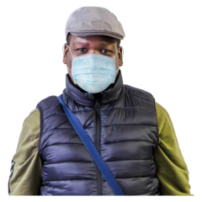 | You still have to wear masks or face shields in places that are inside  (please see exempt mask easy read)
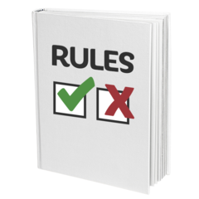 | This is a rule  It is to keep you and other people safe
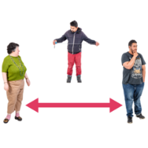  1 metre | You still need to stay 1 metre away from other people  It is safer to stay 2 metres away- but this is not the law anymore
 | Places you can now go
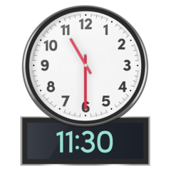  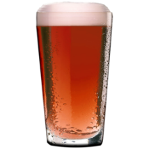  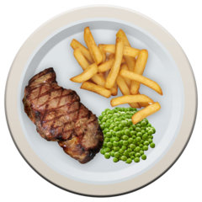  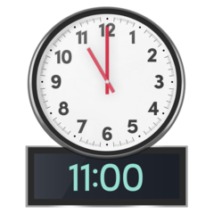  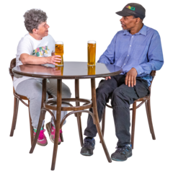  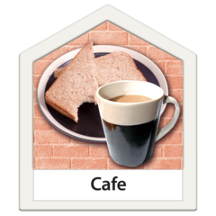  10 | You can go to all restaurants, cafes and pubs - even if they do not serve food  You can be served at the bar or at your table  You can have 10 people at a table that you do not live with  You can stay at your table for as long as you like  You must all wear masks when you are not sat down at the table  You cannot order food or drink after 11pm  Closing time is 11.30pm
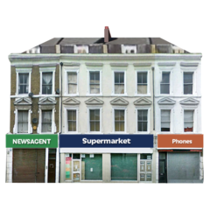 | You can go to the supermarket, post office, chemist and petrol station
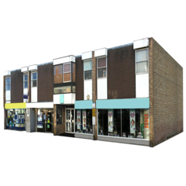 | You can now go to all shops
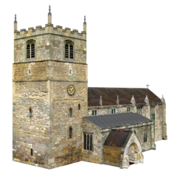 | You can go to church, faith groups, weddings and funerals  There is no limit on the number of people who can go to the service
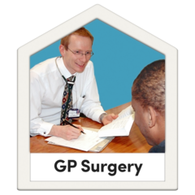  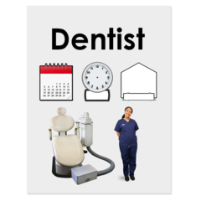 | You can go to the doctor, dentist and any health appointments  You must go on your own unless you need a carer to come with you  Follow instructions from staff
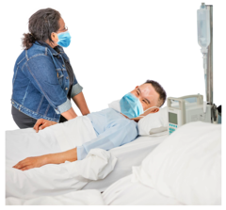 | You can now visit a family member or friend in hospital  The person you want to visit must tell the Ward the names of only two people they would like to see  They are only allowed to see one visitor at a time
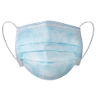  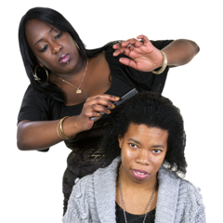 | You can go to hairdressers and beauty salons  You must wear a mask
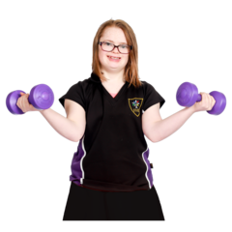 | You can exercise indoors and outdoors  The gym, exercise classes and swimming pool are now open
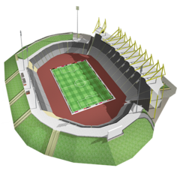 | You can play outdoor sports games  There is no limit on the number of people that can play or watch the game
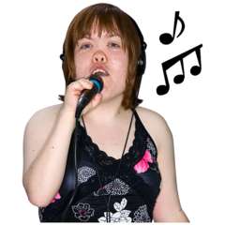  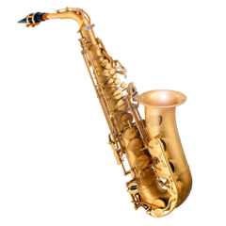 | You can sing and play instruments indoors with other people
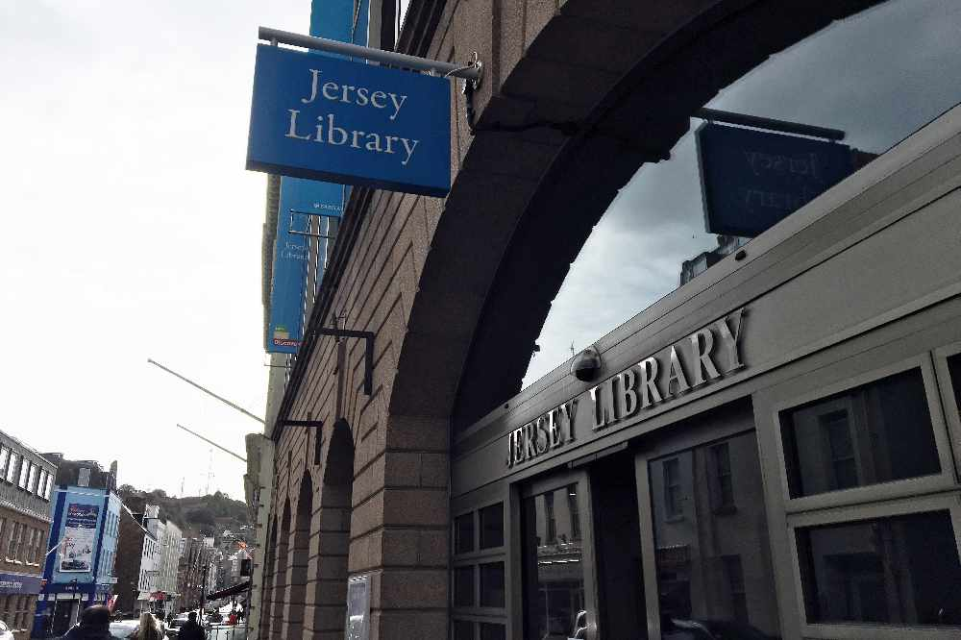 | You can visit the museum and go to the library  Follow instructions from staff
 | Some places are still closed to stop the spread of coronavirus
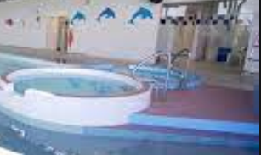 | Saunas, Jacuzzis and steam rooms are still closed
 | Seeing friends and family
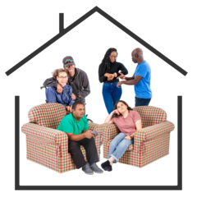  20 | You can have up to 20 people that you do not live with in your home  Try to keep 1 metre away from other people
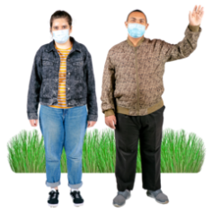  20 | 20 people can meet outdoors  You can meet at the beach, in a park or garden  Try to keep 1 metres away from other people
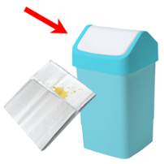  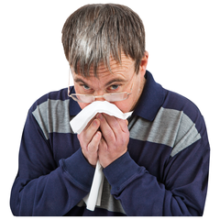 | Remember to keep others safe cough or sneeze into your elbow or a tissue
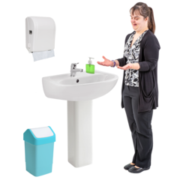 | Wash your hands  - when you get home  - before you eat  - before you touch your face
If you are worried or think you have any symptoms of Coronavirus

You can call the Coronavirus helpline on:
Telephone: 01534 445566

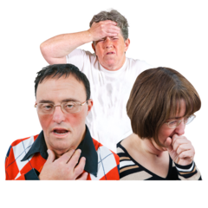  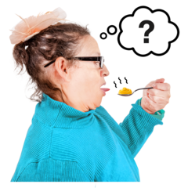 | The three main symptoms are:  - a new cough or one that does not go away  - a high temperature  - loss of smell or taste
 | Stay safe

