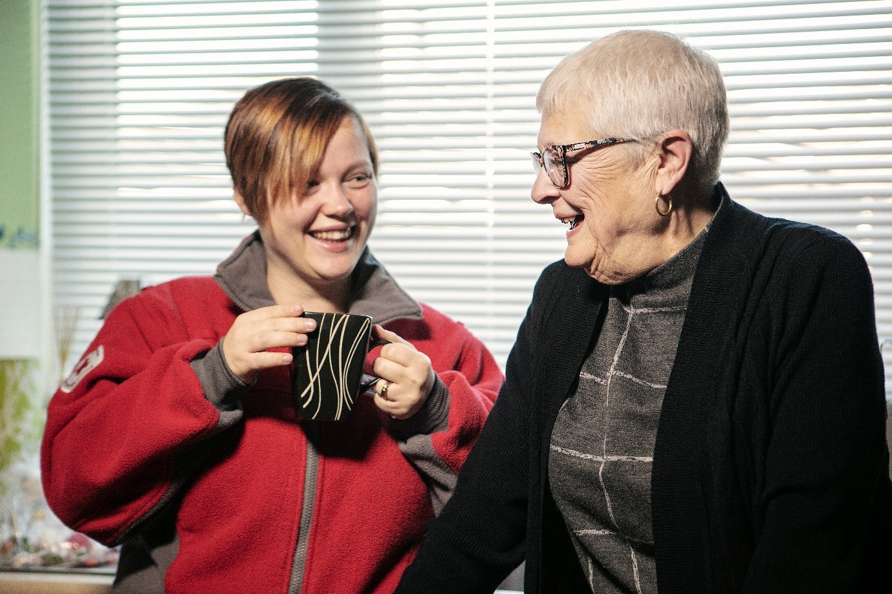
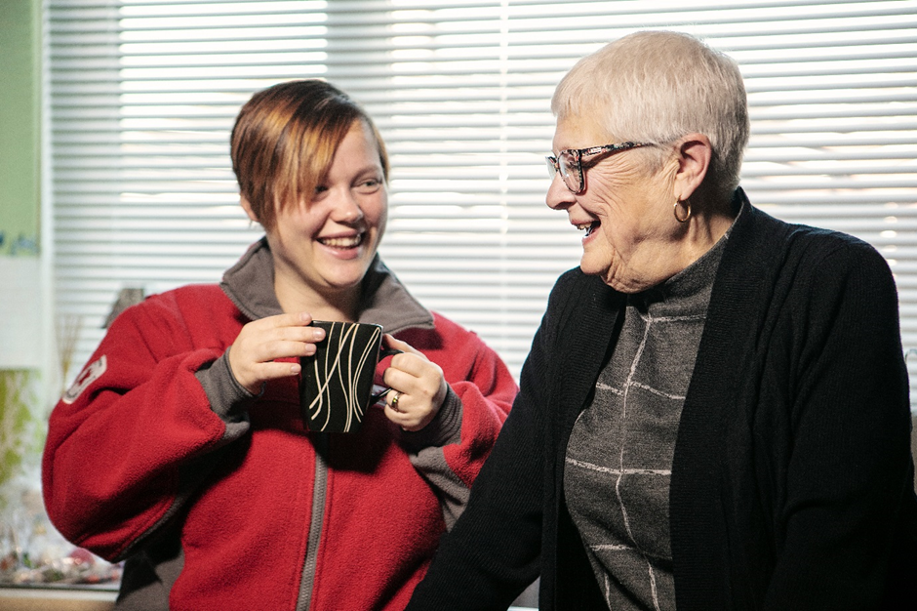

INDEPENDENT LIVING

SERVICE GUIDE JERSEY

WHAT IS THIS DOCUMENT?

This guide gives a general overview of the independent living services provided by the British Red Cross in Jersey as well as our approach to quality.

We have over 30 years’ experience in providing valuable, time-limited support to vulnerable people across the UK (and would now like extend this in the Channel Islands starting in Jersey). We help ensure people can live independently in their own homes – reducing admissions to hospitals, residential and nursing care. Our emphasis will always be on supporting people to lead the life they choose and value.

In some parts of the UK, we hold contracts with local authorities and health commissioners to provide independent living services. The range and availability of our services may vary depending on where you live.
WHAT TYPE OF SUPPORT DO WE OFFER IN JERSEY?

Connecting Community Service

We offer a support that we offer a in the form of a Community Connector service funded by the Jersey Charitable Foundation Trust.
At the British Red Cross, we’re here to support thousands of adults who feel they have nowhere to turn due to loneliness or isolation.
We aim to help each person to feel better connected and be able to enjoy the benefits of being more involved in their local community. Our offer is built around enabling people to realise the things they want to achieve and help them achieve it.
Together we’ll develop a specially tailored plan focused on helping people towards a brighter and better-connected future. For each person, our support looks a little bit different. We can help people to:
Rediscover their interests:
After an introductory chat with one of our local team, we will spend time getting to know each other to explore the person’s interests and what they want to achieve we’ll then identify ways they can start to do these things

Rebuild their independence
Over the next couple of months, we’ll regularly meet up to chat about how they are feeling and give them the support needed to be able to achieve their goals, together we’ll review and make adjustments when needed.
This service can be accessed through a referral from a healthcare professional, through a local community / voluntary group or through self-referral.
OUR

APPROA
CH

TO

QUALITY

The Red Cross aims to provide a high level of quality support to suit your needs. We do this by working to a set of key policies and procedures. Our services are quality-audited, both internally and externally, by care regulators and the local authorities and health commissioners who buy our services. We also ask for regular feedback from the people we support and their family members to help us improve the quality of our services.

Our workforce
We carefully recruit our workforce. We request references from previous employers, check any gaps in employment and carry out DBS checks.
We support our staff and volunteers to follow an on-going induction programme that includes:
- Safeguarding
- Data Matters (Information Governance)
- Moving and Assisting
- Code of Conduct
- Equality, Diversity, and Inclusion: Getting it Right
- Professional Behaviours
- Health & Safety – Mandatory Training
- Protecting the BRC from Fraud Bribery & Corruption
We provide ongoing training that includes
- Support Planning
- First Aid
- Dementia Awareness
- Mental Health First Aid

We also support our workforce to achieve vocational qualifications in relation to health and social care. These qualifications may be relevant to the country they are working in.
This training and personal development is supported by on-going supervision.

Complaints, comments and compliments
We welcome any comments (good or bad!) to find out how we are doing. If you have any feedback about the service provided we would like to hear from you. At any time during the process, a person of your choice such as a friend or relative can act on your behalf.

Information about the complaints, compliments and comments process will be given to you as part of the information pack and will advise on how you can make a complaint, compliment or comment. We value your feedback so please, start by speaking to your support worker, their line manager or a member of the management team:

Operations Manager (Fiona Pearson) - 07734 577914
Service Coordinator (Theresa Radiguet) – 07700 720623

You can also contact our UK national team on the telephone or make contact via our website.

You can contact us about your complaint, compliment or comment at:
https://www.redcross.org.uk/about-us/contact-us/feedback
Email – contactus@redcross.org.uk
Telephone (UK): 0300 4561155

Assessment and Support Planning
We will work closely with you, putting you at the centre of all assessment and planning discussions. We will carefully listen to what you tell us is important to you now and in the future. It is most helpful when you provide the relevant information to enable us to effectively design the most suitable support for you. With you, we will design the best support that identifies what you need; how your needs will be met; what the Red Cross should do to support you; and when your support will be reviewed. All details will be written into a document called a ‘support plan’.

You might want to involve other people, such as your family or friends, in these discussions. The Red Cross will support your decision. You will decide where your support plan will be held and who will have access to it. We will also support these decisions. You have a right to have your support plan reviewed at any time.

(What do you need to do to get the most out of your service?
In the early days when we meet with you we will have a general discussion so that we can all design and suggest ways in which we can support you.

We are committed to providing the best possible service. We want you to be an active participant in your own support, and this means that we will work together to meet your needs. In order for you to get the most out of the support, it is important we work to agreed times and you let us know if you are not going to be available.
We will ask you for an emergency contact number and general information including the name, address and telephone number of your GP.
The service we offer is time-limited and there will come a point at which this arrangement will end. We will do all that we can to ensure you have the support you want. If this support is no longer available from us we will help you to find another service or support from elsewhere.

Health and safety
The Red Cross is governed by and abides by the Health and Safety at Work (Jersey) Law 1989. This means that we set rules and have guidance procedures to protect the health, safety and general welfare of our staff and volunteers and the people that use our services.
During 2020 we have had to review how we work and have introduced new guidelines in regard to how we support people safely through a blend of face-to-face support, remote support and through telephone support (where applicable).
We have also reviewed our PPE guidance for our staff, volunteers, and the people we support. As part of our initial introduction conversation, we will discuss these requirements and regulations with you and how these will be factored into your service and support plan.
Please let us know if you have any concerns about health and safety. We will address these as quickly as possible.
Living your life free from the risk of harm
The Red Cross believes that everybody has the right to live a life that is free from the risk of harm.
Safeguarding Policy
Harm is when another person or people do things that hurt or upset you.
Harm can take many different forms. It can be when somebody: hurts you (physical harm) takes or doesn’t let you use your money or possessions (financial harm) bullies, threatens or upsets you (emotional harm) treats you badly because you come from a different country or because of your sexual orientation (discriminatory harm) touches you when you don’t want to be touched or in ways you don’t want (sexual harm) who cares for you doesn’t give you the medicine, food, care or medical attention you need when you need it (neglect).

All Red Cross staff and volunteers have thorough training to ensure that they know how to support people to keep them safe from harm. They know about different types of harm and the things that indicate that someone might be being harmed.

If you are worried about yourself or someone else, speak to your support worker or someone you know and trust such as a friend, neighbour or a family member and tell them what your concerns are. If you tell the Red Cross about any type of harm we will work with you to put measures in place to protect you.

Children & Families Hub 01534 519000 childrenandfamileshub@gov.je
Emergency contact numbers for contacting Jersey’s Safeguarding Team Children are: 612612
at Work (Jersey) Law 1989
Single Point of Contact SPOR – Tel:01534 444440 SPOR@health.gov.je
Out of Hours Emergency Adult Protection Hospital switchboard 442000 or Jersey Police on 612612H

If you think a crime may have been committed, or in an emergency, or you suspect a threat to life please contact the States of Jersey Police on 999

Non - emergency incidents/allegations Tel: 01534 612612/612300

If a safeguarding issue is suspected call the above and ask for the Public Protection Unit (PPU)

Confidentiality
During the time in which you receive any support from the Red Cross we will collect, record and use certain personal information about you.
This information may be recorded on a support plan or a referral form, for example.

The confidentiality and security of your information is of paramount concern to the Red Cross. To this end, we comply with Data Protection Legislation and are committed to maintaining your personal information in accordance with the Data Protection Act 2018 (DPA 2018) and EU General Data Protection Regulation (GDPR) 2018. We will take all reasonable steps to ensure that your personal information is kept secure against unauthorised access, loss, disclosure or destruction. You can be assured that at all times your information is treated in strict confidence.
If we have reason to believe you, the person for whom you care or someone else is at risk of harm or if there is a legal requirement for us to do so, there may be a need to share some information with other people. At all times this will be discussed with you.

We may need to share your personal information with other providers involved in your support. When we design your support we will discuss this with you.
At any time, you have the right to request access to your personal information that we have collected and to request amendments to personal information about you to ensure its accuracy and completeness. To make a request for access to personal information we may have collected, disclosed or used about you or to request that your personal information be amended please contact your local service manager or email: dataprotection@redcrtoss.org.uk

Equality and diversity policy
The Red Cross makes no discrimination as to nationality, race, religious beliefs, class or political opinions. We work with whoever needs support, irrespective of background or belief, as stated in our equality and diversity policy.

Freedom of Information (FOI)
The Red Cross abides by the Freedom of Information (FOI) Act 2000 for England, Wales and North Ireland and the FOI 2002 for Scotland respectively. the Freedom Of information (Jersey) Law 2011

Professional service

The Red Cross provides a professional service and upholds boundaries that observe individuals’ rights, dignity and respect.
This can only happen when our staff and volunteers and the people that we support agree to appropriate levels of conduct. In other words, this needs to be a mutual agreement.
Inappropriate behaviour such as bad language or aggression will lead to the service being terminated.

Service User Statement

We are a diverse organisation, and we strive to ensure our people represent the diverse communities we support. We seek to ensure that our organisation and services are relevant and accessible to all. Our people always have the right to be treated with dignity and respect and should be able to do their jobs without prejudice or intimidation. The British Red Cross has a zero- tolerance policy when it comes to intimidation, abuse against our people and prejudice, such as racism and homophobia.

As such, and in line with policy, we reserve the right to withdraw service from anyone who does not respect the rights of our people to work in an environment free from prejudice, intimidation, and abuse.
We value fresh perspectives and insights gained by involving and welcoming people from the widest possible diversity of background, culture and experience. We thank you for supporting this position and for treating our people with dignity and respect.

Rights and Resonsibilities

Rights
- I have the right to be treated fairly and equally and not be discriminated against.
- I have the right to expect that my access to BRC services is not affected or refused because of unlawful discrimination based on my age, disability, sex or sexuality, gender reassignment, marriage or civil partnership, pregnancy or maternity, race (including colour, nationality, ethnic or national background), or religion or belief.
- I have the right to be treated with consideration, dignity and respect when accessing and using BRC services.
- My right to privacy and confidentiality must be respected by BRC.
- I have the right to be involved in decisions about my support.
- I have the right to provide information about the support I receive, what is working and what could be improved.
- My support must be provided as safely as possible.
- I have a right to expect that everyone working in BRC has the appropriate skills and training for their job.
- I have the right to clear and open communication about my care and support.
- I have the right to be given information about my care and support in a way I can understand and, in a format, or language that meets my needs.
- I have the right to expect BRC to check whether I have understood the information they have given me and whether I would like more information.
- I have the right to make formal complaints if need be.
Responsibilities
- I understand I should treat BRC staff and volunteers with consideration, dignity and respect when accessing and using BRC services
- I understand that I should keep my appointments with BRC
- I understand that for home visits, I should make sure I am in at the agreed time.
- I understand I should let BRC know if I need to cancel an appointment or home visit
- I understand I should let BRC know if I change my address or telephone details.
- I understand BRC can withdraw a service in some situations, for example if I am physically or verbally abusive to people delivering the service.
HOW CAN I GET MORE INVOLVED?

If you wish to get more involved in fundraising, volunteering, activities or events with the British Red Cross please contact your local Red Cross office for further information. Details can be found in the local fact sheet accompanying this guide or by visiting www.redcross.org.uk.

HOW DO I GET IN TOUCH?

LOCAL OFFICE:
British Red Cross
Fire Service Headquarters
Rouge Bouillon
St Helier
Jersey JE2 3ZA

Tel: 01534 639895
Mobile: 07700 720623

HEAD OFFICE:
British Red Cross
UK Office
44 Moorfields
London EC2Y 9AL
Tel: 0344 871 11 11 (+ 44 2071 3879 00 from abroad)
Fax: 020 7562 2000
Textphone: 020 7562 2050
Email: information@redcross.org.uk

The British Red Cross Society, incorporated by Royal Charter 1908, is a charity registered in
England and Wales (220949) and Scotland (SC037738) and Isle of Man (0752) and Jersey (430)

